**Function Expression**

Function Expression is a function begins with var keyword.

Function expression is an **Anonymous Function** as the function keyword has not function name. So it’s considered [first class function](First%20class%20&%20higher%20order%20functions.docx).

**Syntax:**

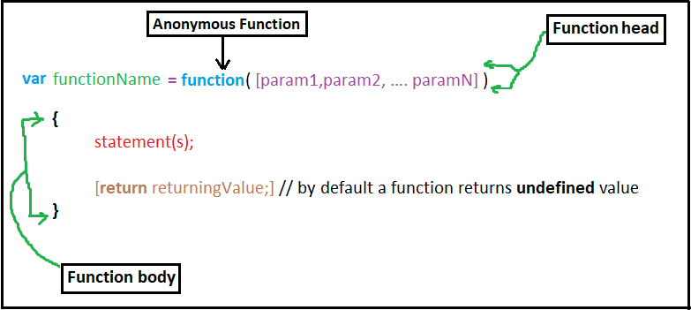

**Note:**

* Return statement In the previous syntax is an optional statement as if a function has an arguments then it should has returning statement and if the function hasn’t parameters, then it shouldn’t has returning statement.
* Return value in function by default is **undefined.**
* Functions doesn’t execute by itself, It executes only when we call them.
* We can call one function several times and in anywhere.

**Example 1:**

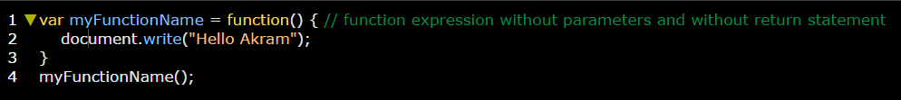

**Example 2:**

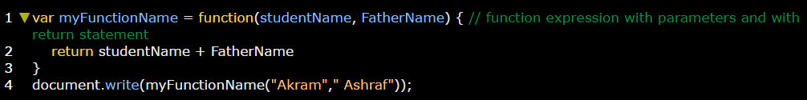

**Example 3:**

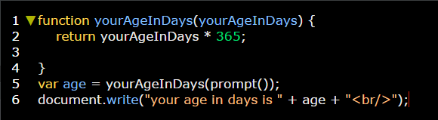

**Example 4:** on uninitialized function parameters.

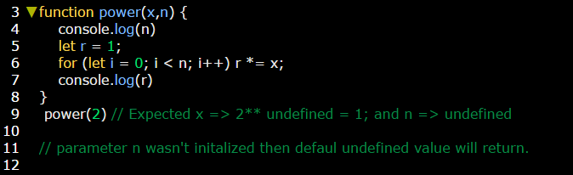

**Example 5:** determine default value for function parameters instead of undefined value.

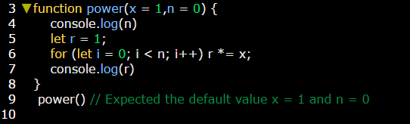

[**The difference between function declaration and function expression**](Function%20declaration%20vs%20expression.docx)